**ASSIGNMENT -2**

**Pharma Sales Dashboard**

|  |  |
| --- | --- |
| Student Name | HARITHA M |
| Student Roll Number | 921319104054 |

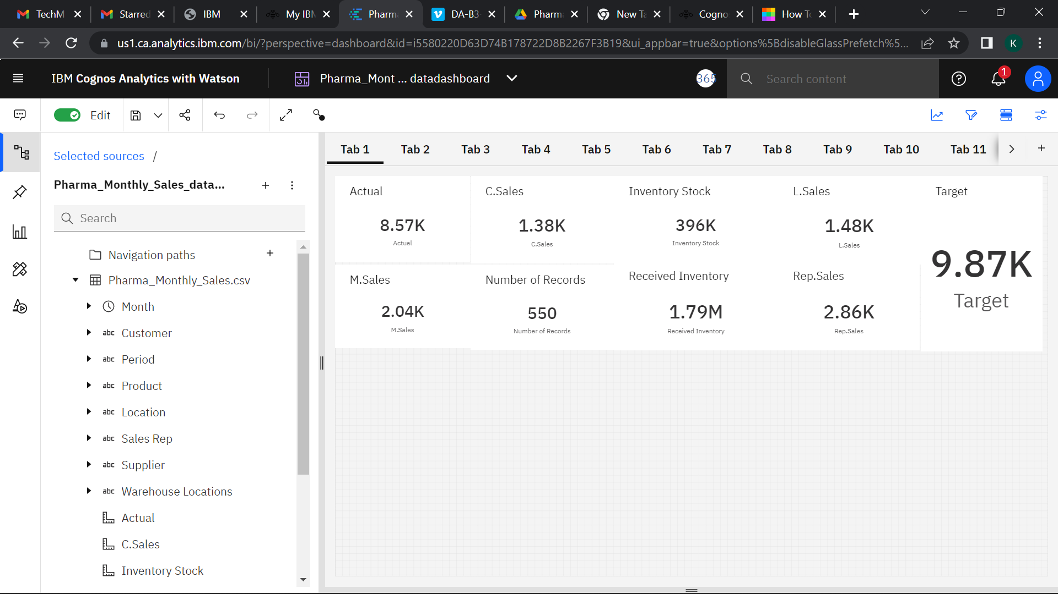

**SALES BY CUSTOMER**

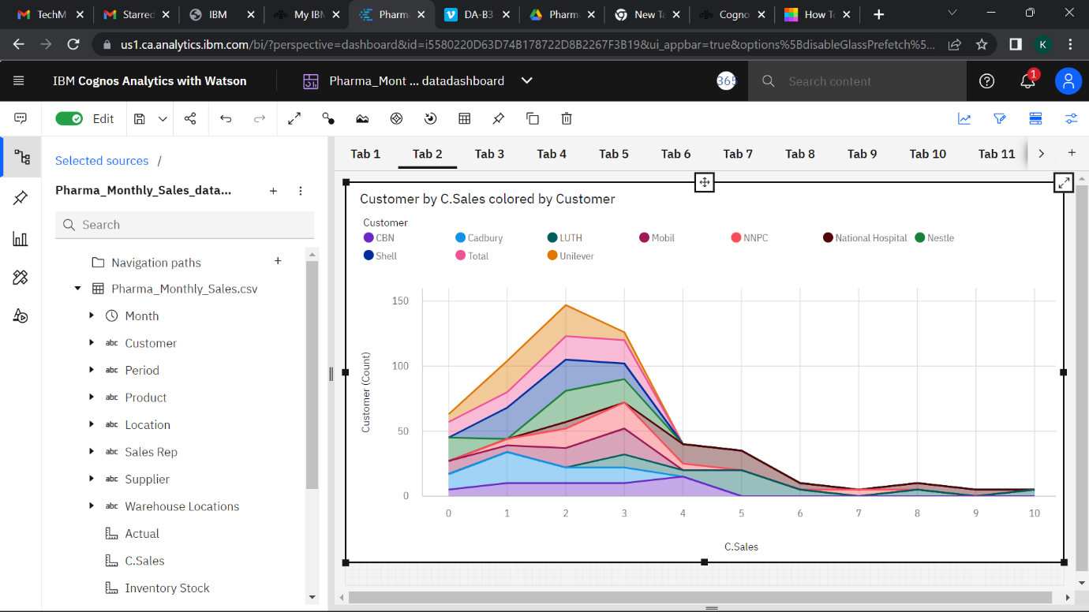

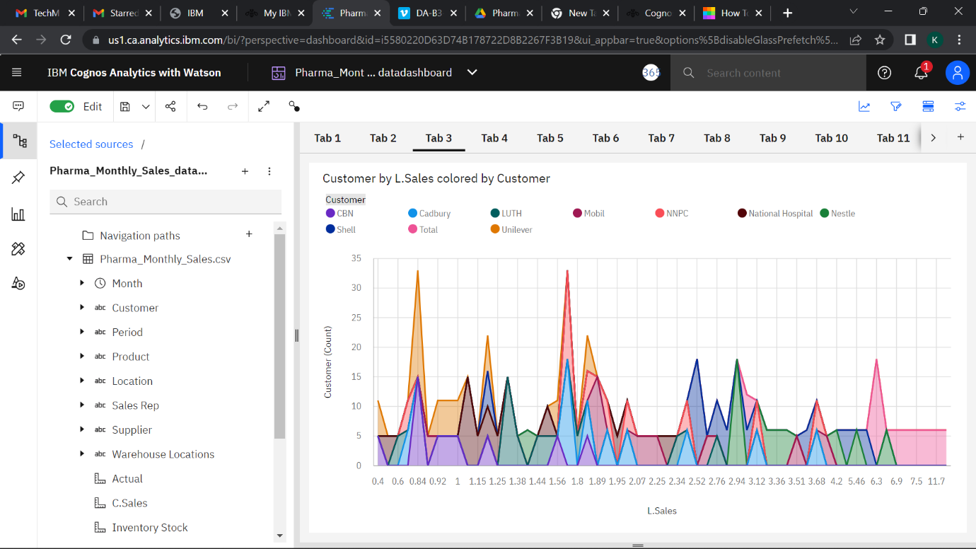

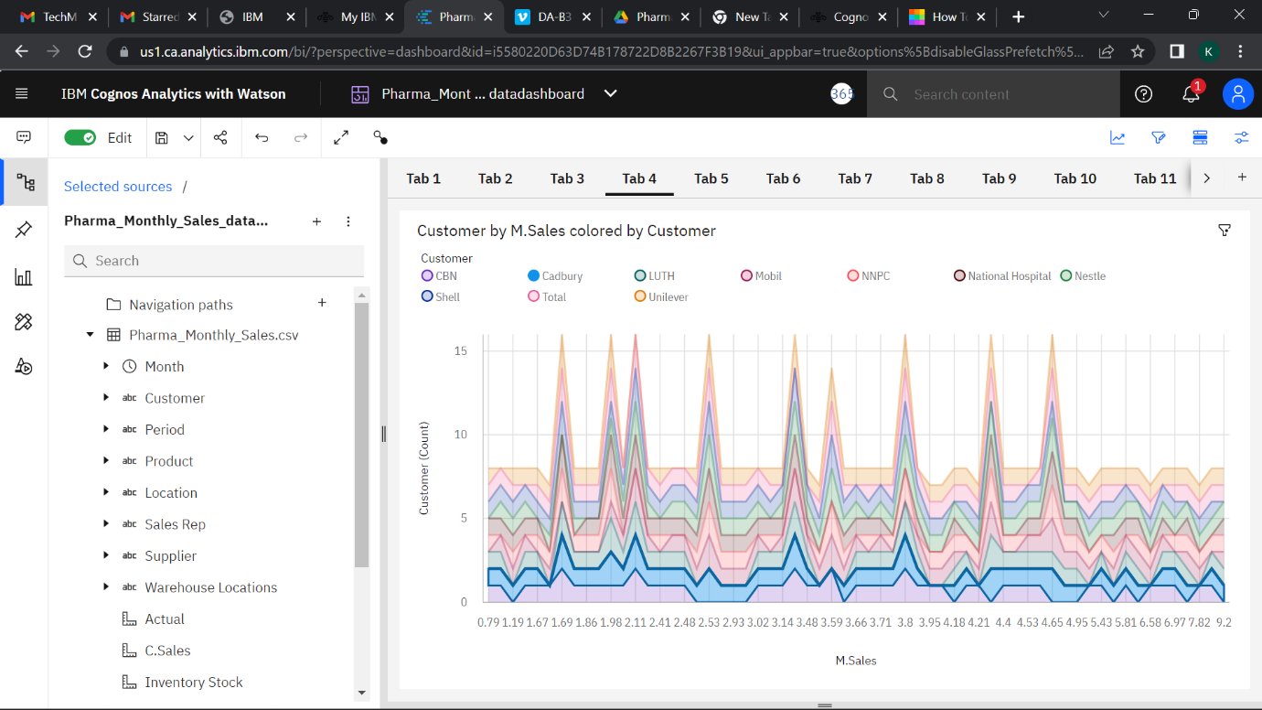

**SALES BY LOCATION**

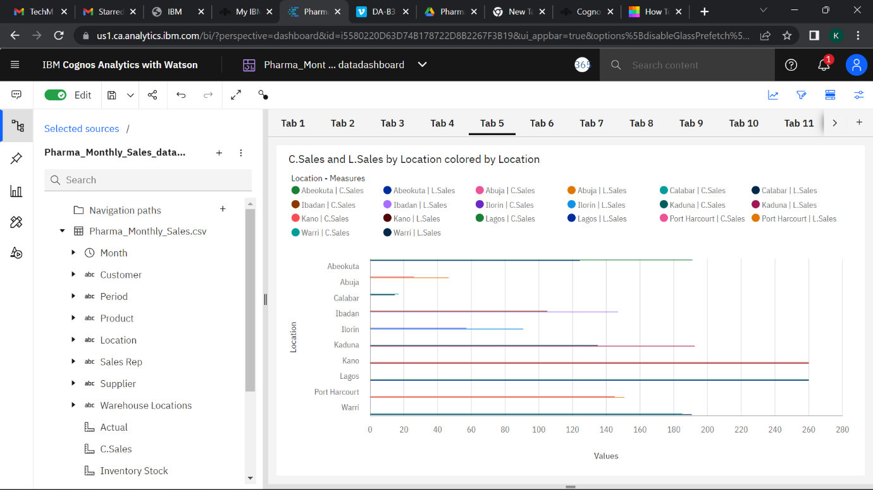

**SALES BY SALES REPRESENTATIVE**

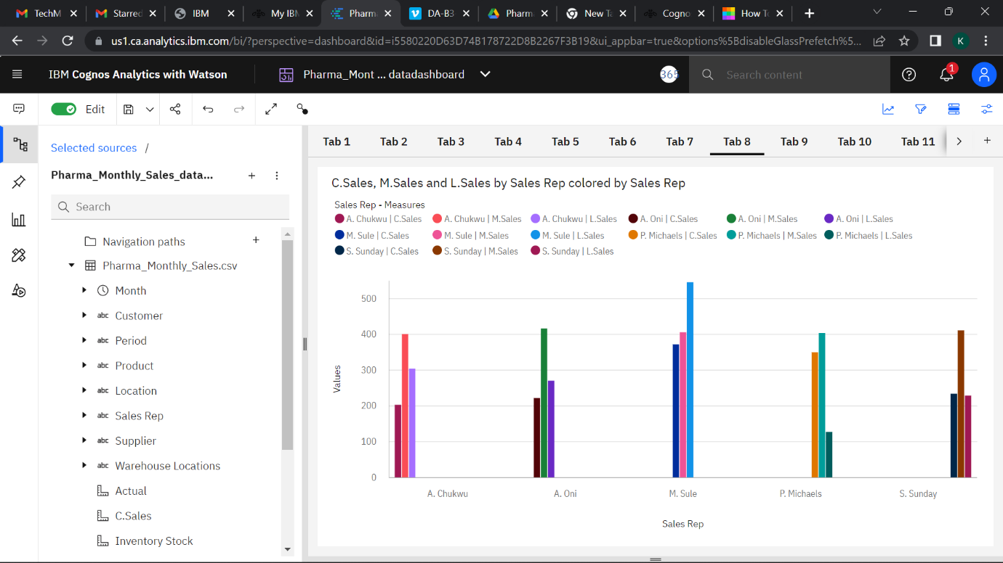

**RECEIVED INVENTORY FROM SUPPLIER**

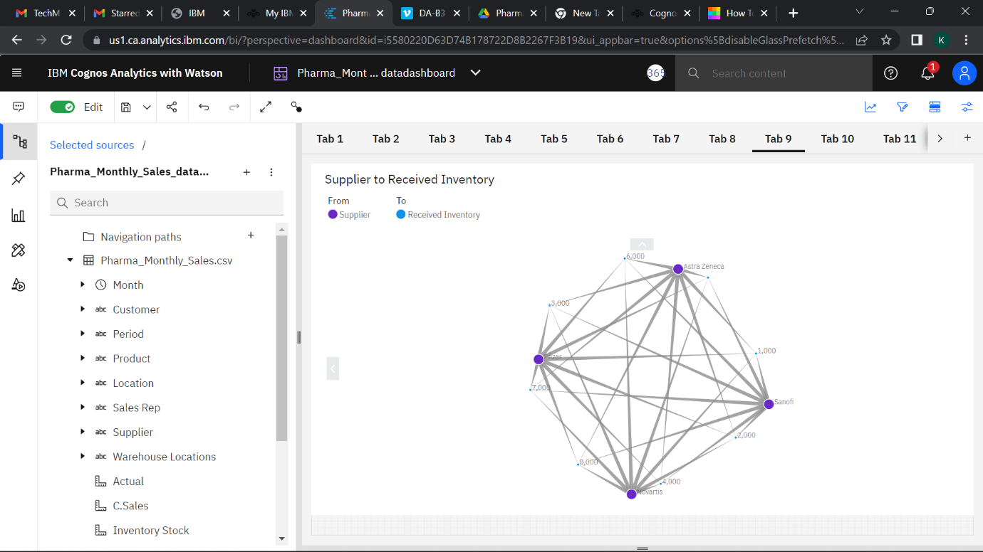

**INVENTORY STOCK FOR WAREHOUSE LOCATIONS**

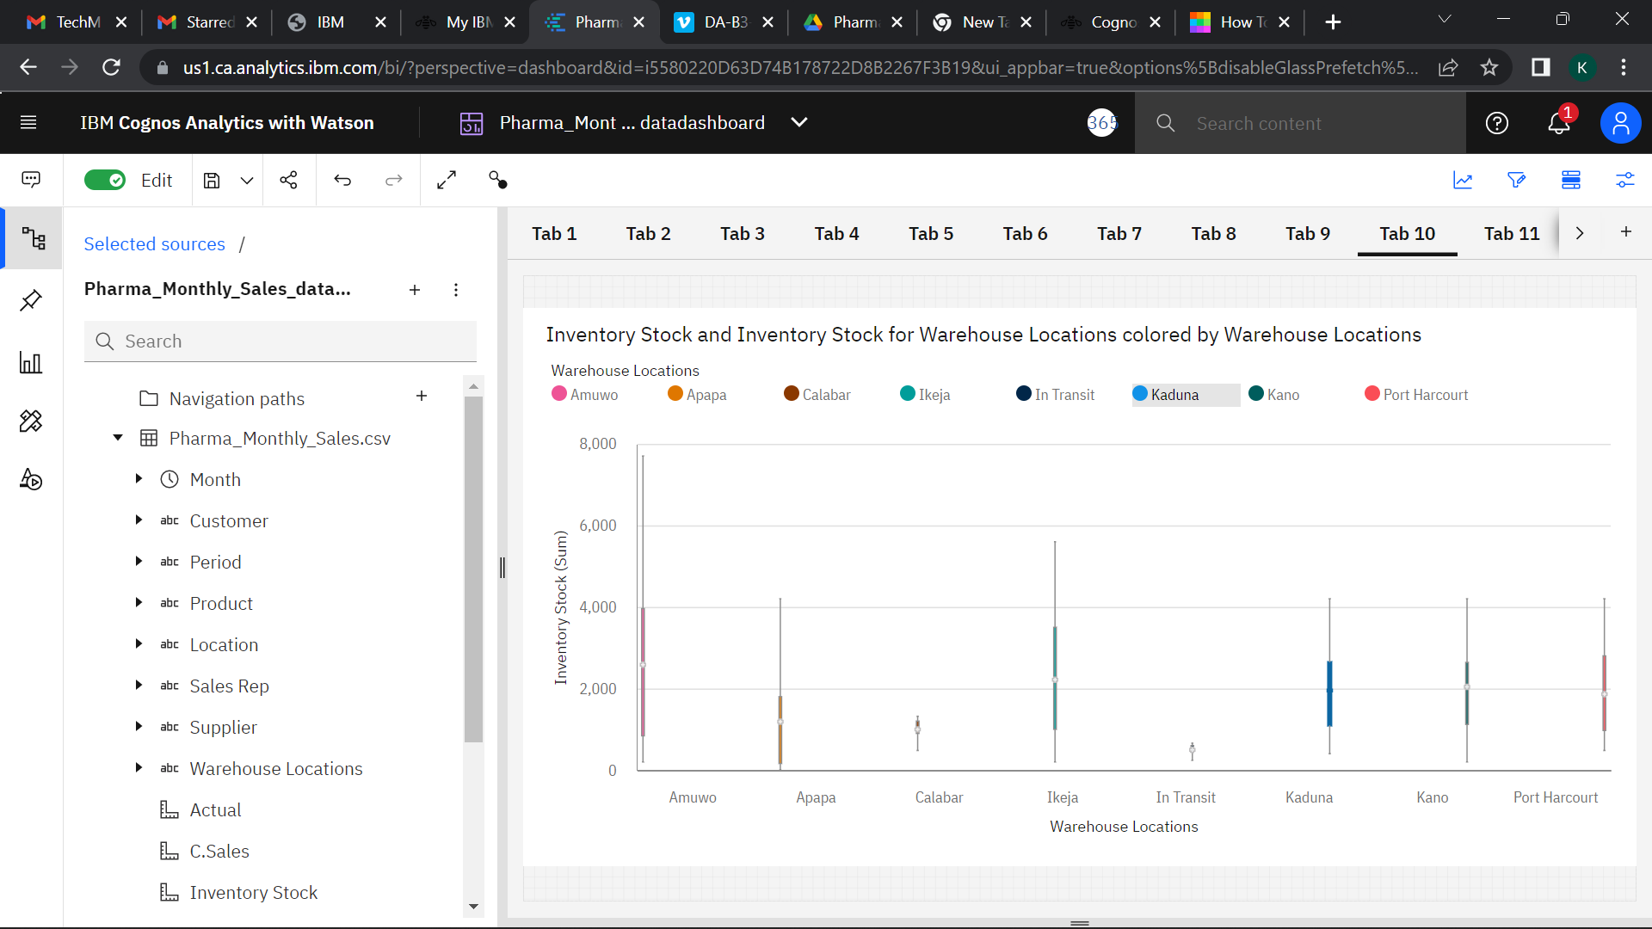

**ACTUAL AND RECEIVED INVENTORY BY MONTH** 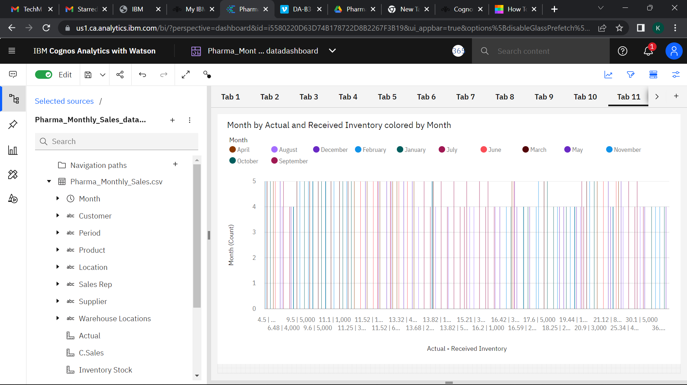

**SALES TREND**

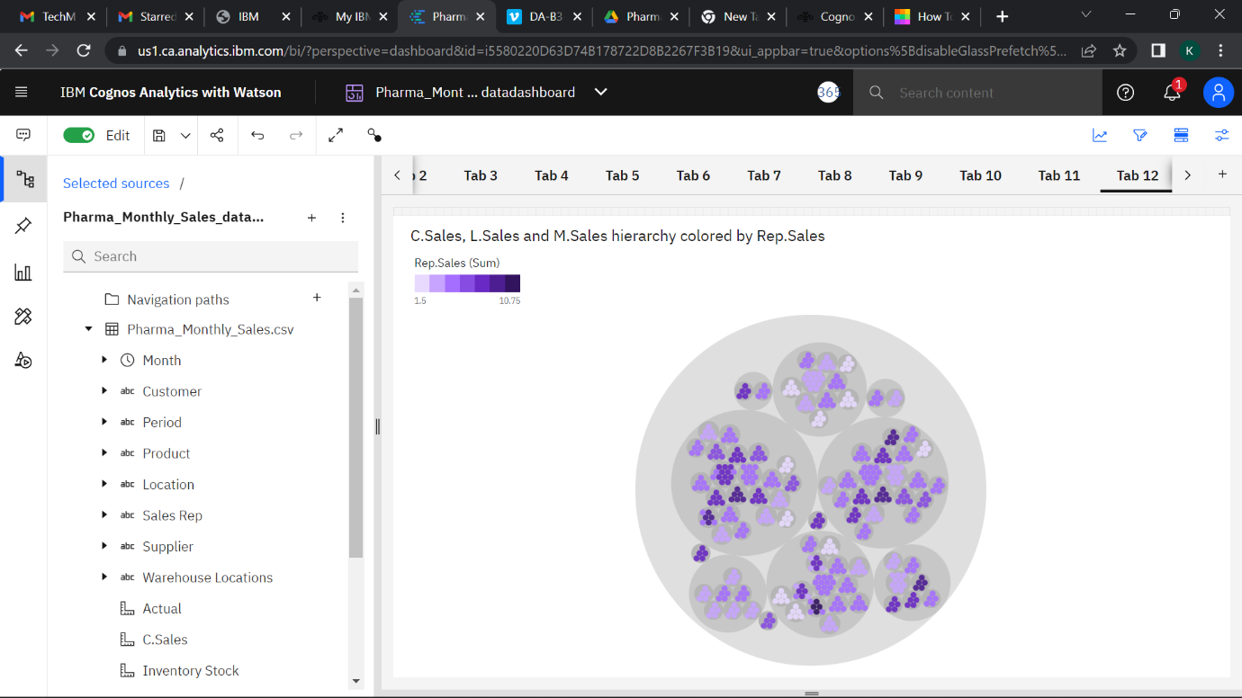

**MONTHLY SALES**

